Supplementary Information

GPJet: Learning Electrohydrodynamic Jet Printing Dynamics with Physics-Informed Gaussian Processes

Athanasios Oikonomou1,6, Theodoros Loutas1, Dixia Fan2,3, Filippos Tourlomousis4,5,6*

1Mechanical Engineering, University of Patras, Patras, Greece

2Mechanical and Material Engineering, Queen’s University, Kingston, ON, Canada K7L 3N6

3Ingenuity Labs, Queen’s University, Kingston, ON, Canada K7L 3N6 3

4The Center for Bits and Atoms, Massachusetts Institute of Technology, Cambridge, MA, USA

5Biomolecular Physics Laboratory, Institute of Nuclear & Radiological Sciences and Technology, Energy & Safety, NCSR Demokritos, Athens, Greece

6SuperLabs, Athens, Greece

# Nomenclature

|  |  |  |
| --- | --- | --- |
| **Parameters: Symbol – Description – Units** | | |
| **Process** | | |
|  | Needle tip radius |  |
|  | Needle tip to collector distance |  |
|  | Time |  |
|  | Pressure |  |
|  | Volumetric flowrate |  |
|  | Voltage applied to needle tip |  |
|  | Voltage applied to collector |  |
|  | Needle temperature |  |
|  | Collector temperature |  |
|  | Collector speed |  |
|  | Critical collector speed |  |
| **Jet** | | |
|  | Jet radius |  |
|  | Jet speed in y axis |  |
|  | Jet speed in x axis |  |
|  | Jet speed on impact point |  |
|  | Angle left |  |
|  | Angle right |  |
|  | Area |  |
|  | Lag distance |  |
| **Physics Jet Model** | | |
|  | Reynolds number |  |
|  | Peclet number |  |
|  | Capillary number |  |
|  | Electrostatic force parameter |  |
|  | Bond number |  |
|  | Nahme-Griffith number |  |
|  | Deborah number |  |
|  | Local Biot number |  |
|  | Dimensionless temperature |  |
|  | Temperature factor |  |
|  | Aspect ratio |  |
|  | Mobility factor |  |
|  | Ratio of solvent to zero-shear-rate viscosity |  |
|  | Dielectric constant ratio |  |
|  | Surface charge density |  |
|  | The tangential component of the electric field to the jet surface |  |
|  | Τemperature dependence of the zero-shear-rate viscosity |  |
|  | Activation energy |  |
|  | Ideal gas constant |  |
|  | Temperature change necessary to substantially alter the rheological properties of the fluid |  |
|  | Total axial normal stress |  |
|  | Total radial normal stress |  |
|  | Axial polymeric stress |  |
|  | Radial polymeric stress |  |
| **Geometrical model** | | |
|  | Steady coiling radius |  |
|  | Jet’s trace on the collector |  |
|  | The contact point |  |
|  | Deposited jet’s arc length |  |
|  | Polar radius coordinate |  |
|  | Polar angle coordinate |  |
|  | Curvature at the bottom of the jet |  |
| **CV Metrology** | | |
|  | Processing time |  |
|  | Frames per second |  |
|  | Calibration factor |  |
|  | Indicating every how many pixels along the z-axis we perform computations |  |
| **Gaussian Processes** | | |
|  | Dataset, available input-output pair of observation data |  |
|  | Unknown function to be approximated |  |
|  | Mean function determining the unknown function |  |
|  | Covariance matrix determining the unknown function |  |
|  | Kernel reflecting the prior available knowledge on the unknown function |  |
|  | Kernels hyperparameters to be trained |  |
|  | Mean prediction of GP model |  |
|  | Variance prediction of GP model |  |
|  | Number of available data |  |
| **Multifidelity Modeling** | | |
|  | High fidelity GP model |  |
|  | Low fidelity GP model |  |
|  | A scaling constant quantifying the correlation between the two models |  |
|  | Another GP modeling the bias term for the high-fidelity data |  |
|  | Number of low fidelity data available |  |
|  | Number of high fidelity data available |  |
| **Active Learning and Bayesian Optimization** | | |
|  | Acquisition function |  |
|  | Parameter specifying the least required improvement |  |
|  | The normal cumulative distribution function |  |
|  | The normal probability distribution function |  |
|  | Parameter specifying reliability of confidence intervals |  |
| **Performance Metrics** | | |
| RMSE | The Root Mean Squared Error Performance Metric measures the average magnitude of the error between the predicted values and the true values. | - |
| MCIW | The Mean Confidence Interval Width Performance Metric measures the average width of a confidence interval. | - |
| Min. Regret | The Minimum Regret Performance Metric quantifies how well a method works at finding the optimum. | - |

# Dataset

Video S1 and Video S2 published by P. Dalton [5] were chosen as the dataset to be used for this paper. As described a Sony Alpha 7 (Sony Corp. Japan) digital camera was used with a Nikon ED 200 mm lens (Nikon Corp. Japan). 1080 p resolution videos of the nozzle, jet and collector were taken at 50 frames per second. Process hyperparameters were set to 8 m s-2 and 500 m s-3 maximal stage acceleration and jerk, a 22G nozzle was used, polymer temperature was set to 87 o C and the voltage to the collector was set to -1.5kV, while the voltage to the nozzle was set to +5.75kV.

For Video S1 air pressure feeding the nozzle was set to 1.2 bar and the distance between nozzle and collector was set to 3.5mm with a standard deviation 0.1mm. Collector’s speeds tested in Video S1 were 191.25 mm s-1, 212.5 mm s-1, 255 mm s-1, 340 mm s-1, 510 mm s-1, 850 mm s-1, 1530 mm s-1 and 2890 mm s-1.

For Video S2 air pressure feeding the nozzle was set to 2.4 bar and the distance between nozzle and collector was set to 4.5mm with a standard deviation 0.1mm. Collector's speeds tested in Video S2 were 292.5 mm s-1, 520 mm s-1, 1300 mm s-1 and 4420 mm s-1.

First, videos were split based on the collector speed setting. Second, video frames were cropped to remove redundant pixels that would result to increased processing time. For real time video processing the user would need to specify the region of interest in the frame, so that we can crop it and dispose of needless information, as well as the position of the nozzle, the collector, and a factor, which represents the length of the Taylor cone depended on the nozzle's diameter.

# Supporting Figures

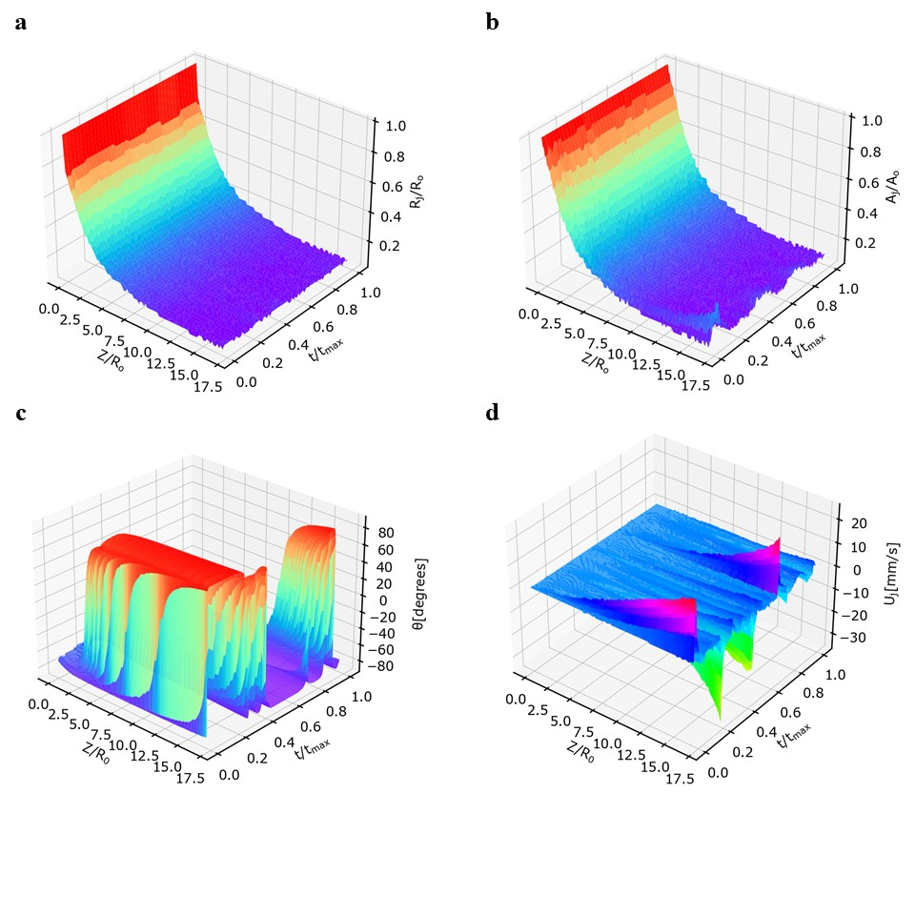

**Figure 1:** **Features Extracted from Computer Vision Module**. **a**) Normalized jet radius () obtained from the computer vision metrology module of the GPJet framework plotted against the normalized jet length () and the normalized time (). **b**) Normalized jet area () obtained from the computer vision metrology module of the GPJet framework plotted against the normalized jet length () and the normalized time (). **c**) Jet angles () obtained from the computer vision metrology module of the GPJet framework plotted against the normalized jet length () and the normalized time (). **d**) Jet velocities () obtained from the computer vision metrology module of the GPJet framework plotted against the normalized jet length () and the normalized time ().

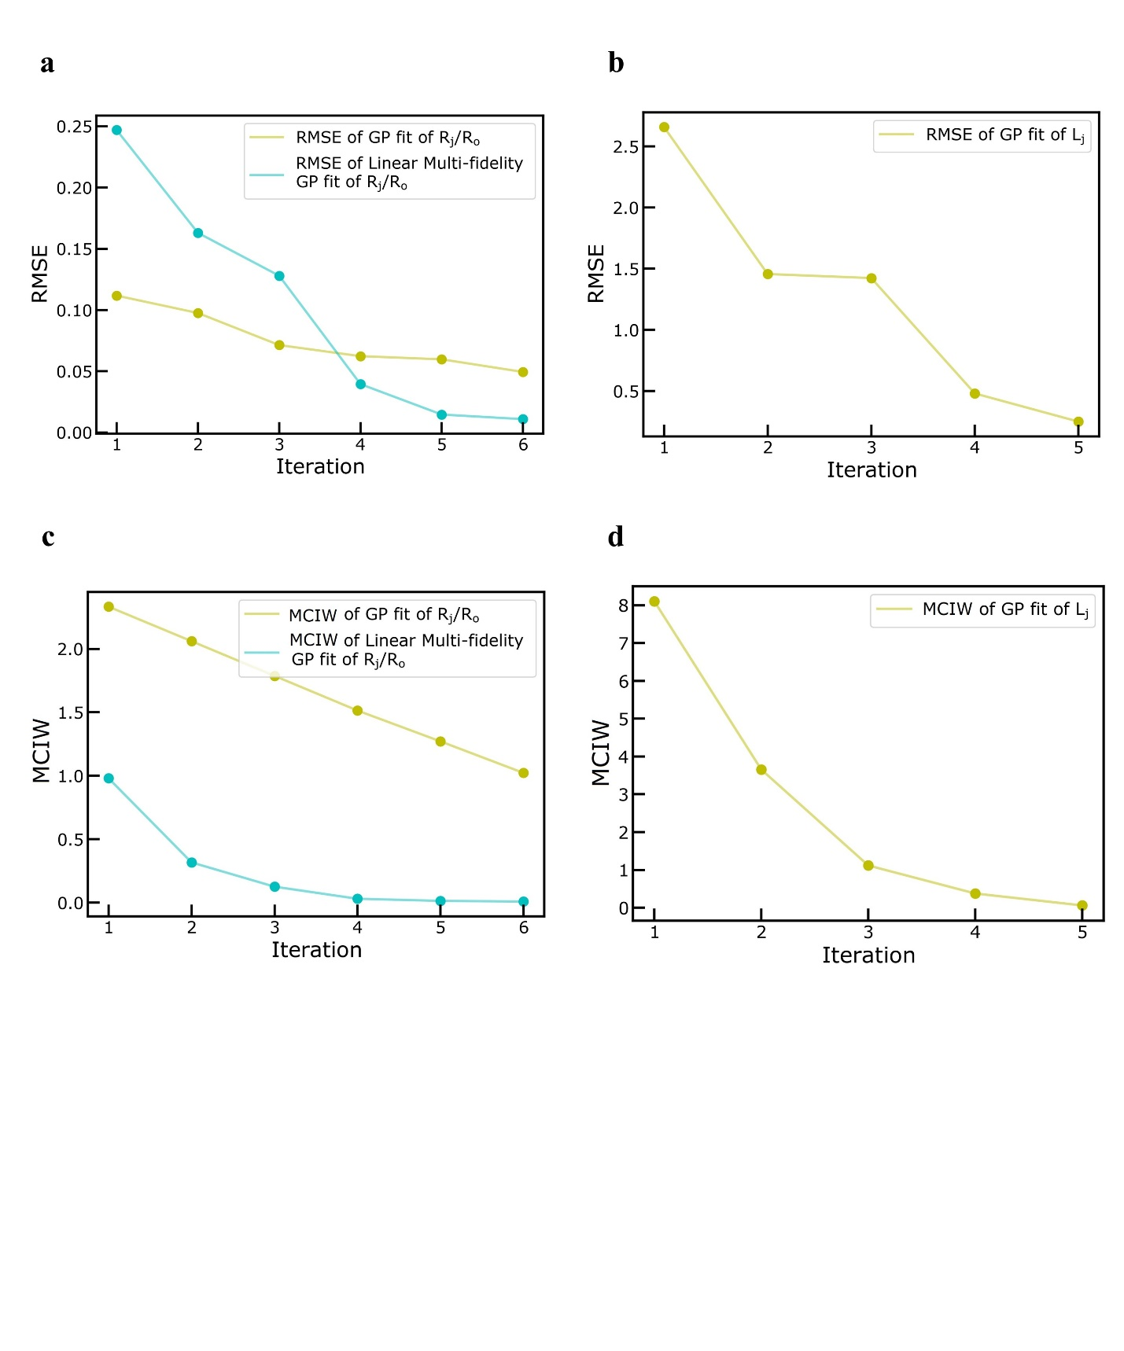

**Figure 2: Performance Metrics Evolution for Active Learning Tasks. a)** Root Mean Squared Error (RMSE) evolution after each iteration, regarding the normalized jet radius (). **b)** Root Mean Squared Error (RMSE) evolution after each iteration, regarding the lag distance . **c)** Mean Confidence Interval Width (MCIW) evolution after each iteration, regarding the normalized jet radius (). **d)** Mean Confidence Interval Width (MCIW) evolution after each iteration, regarding the lag distance .

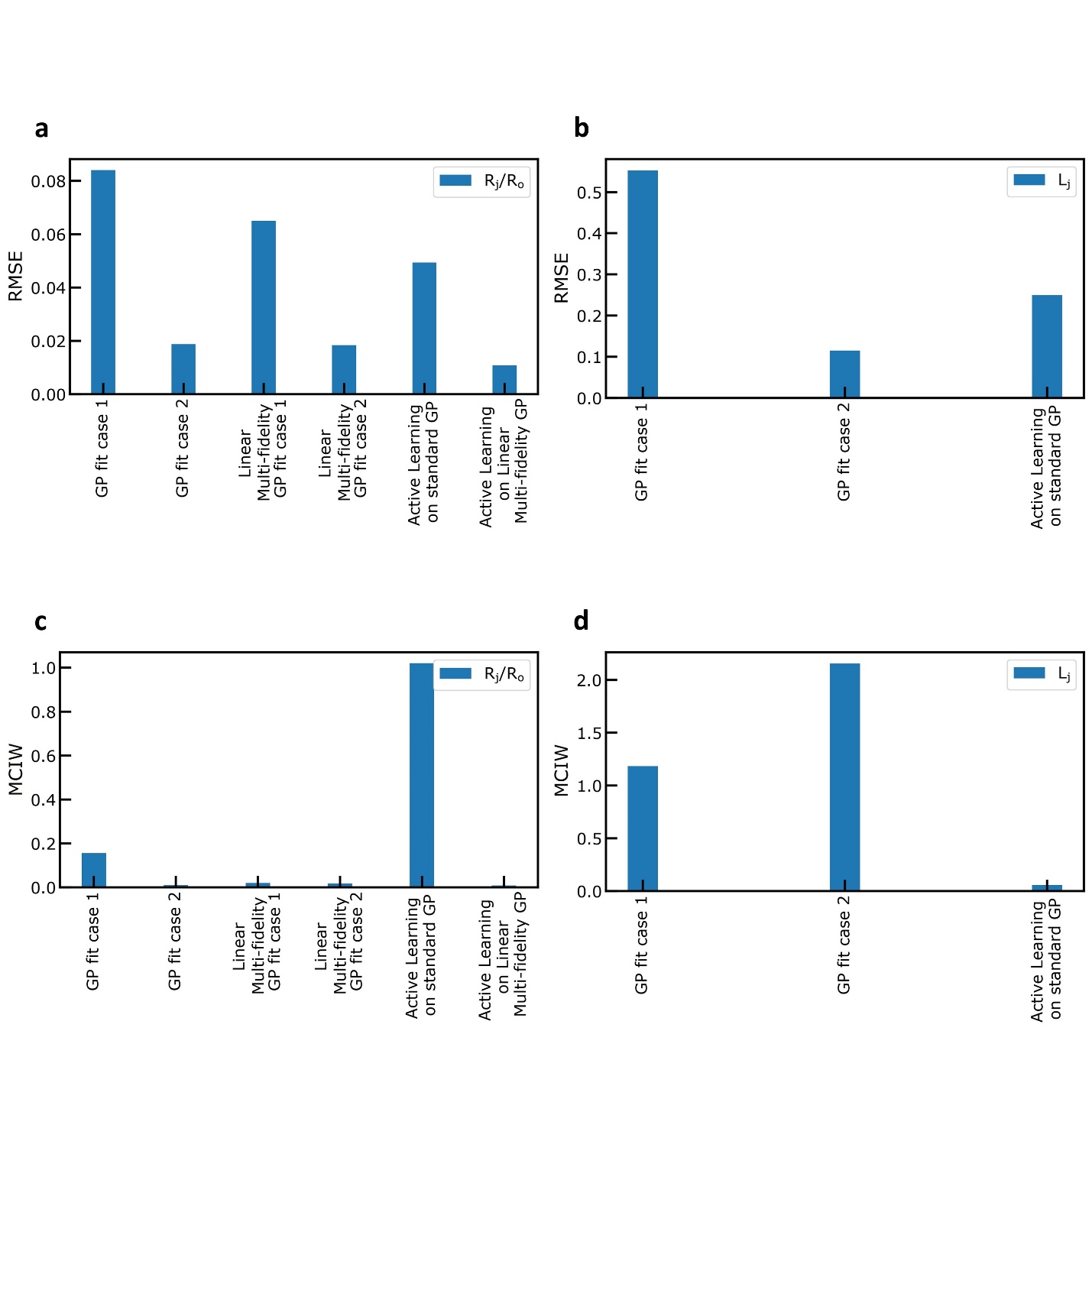

**Figure 3: Collective Performance Metrics for Regression and Active Learning Tasks. a)** Root Mean Squared Error (RMSE) for every case, regarding the normalized jet radius (). **b)** Root Mean Squared Error (RMSE) performance metric, for every case, regarding the lag distance . **c)** Mean Confidence Interval Width (MCIW) performance metric, for every case, regarding the normalized jet radius (). **d)** Mean Confidence Interval Width (MCIW) performance metric, for every case, regarding the lag distance .

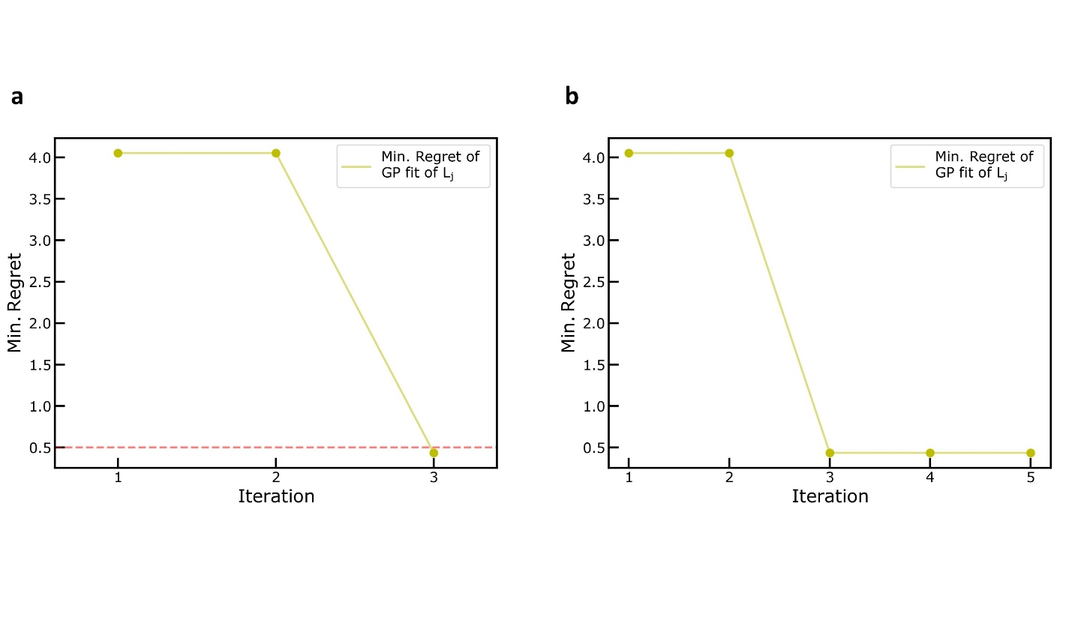

**Figure 4: Performance Metrics. a)** Minimum Regret Performance Metric evolution, after each iteration, regarding the Bayesian Optimization Task to find the minimum lag-distance . **b)** Minimum Regret Performance Metric evolution, after each iteration, regarding the Active Learning Task to explore the design space of lag-distance for specific speed ratios (.

# References

[5] Accurate Prediction of Melt Electrowritten Laydown Patterns from Simple Geometrical Considerations **??

[6] Bradski, G.R., "Real time face and object tracking as a component of a perceptual user interface," Applications of Computer Vision, 1998. WACV '98. Proceedings., Fourth IEEE Workshop on Applications of Computer Vision, vol., no., pp.214,219, 19-21 Oct 1998

[7] D. Comaniciu, P. Meer: Mean shift: A robust approach toward feature space analysis. [IEEE Transactions on Pattern Analysis and Machine Intelligence](https://fr.wikipedia.org/wiki/IEEE_Transactions_on_Pattern_Analysis_and_Machine_Intelligence) (TPAMI), vol.24, p. 603-619, 2002.

[8] Gary Bradski and Adrian Kaehler: Learning OpenCV: Computer Vision with the OpenCV Library, O'Reilly Media, 555 pages, 2008

[9] Jianbo Shi and Carlo Tomasi. Good features to track. InComputer Vision and Pattern Recognition, 1994. Proceedings CVPR'94., 1994 IEEE Computer Society Conference on*,* pages 593–600. IEEE, 1994.

[10] ["Intel Hyper-Threading Technology, Technical User's Guide"](https://web.archive.org/web/20100821074918/http:/cache-www.intel.com/cd/00/00/01/77/17705_htt_user_guide.pdf) . p. 13. Archived from [the original](http://cache-www.intel.com/cd/00/00/01/77/17705_htt_user_guide.pdf) on 2010-08-21.

[11] Zhmayev, E.; Zhou, H.; Joo, Y. L. Modeling of non-isothermal polymer jets in melt electrospinning. Journal of Non-Newtonian Fluid Mechanics 2008, 153, 95-108.

[12] C.P. Carroll, Y.L. Joo, Electrospinning of viscoelastic Boger fluids: modeling and experiments, Phys. Fluids 18 (2006) 053102.

[13] N. Mayadeo, K. Morikawa, M. Naraghi, M. J. Green, J. Polym. Sci., Part B: Polym. Phys. 2017, 55, 1393.

[14] Brun, P.-T.; Audoly, B.; Ribe, N.M.; Eaves, T.S.; Lister, J.R. Liquid ropes: A geometrical model for thin viscous jet instabilities. Phys. Rev. Lett. 2015.

[15] Jawed, M.K., Brun, P.-T.; Reis, P.M. A geometric model for the coiling of an elastic rod deployed onto a moving substrate. J. Appl. Mech. 2015.

[16] Habibi, M.; Najafi, J.; Ribe, N.M. Pattern formation in a thread falling onto a moving belt: An “elastic sewing machine”. Phys. Rev. E 2011.

GPs

[17] C. E. Rasmussen & C. K. I. Williams, Gaussian Processes for Machine Learning, the MIT Press, 2006, ISBN 026218253X.

[18] Ren, J., Cai, J. & Li, J. High precision implicit function learning for forecasting supercapacitor state of health based on Gaussian process regression. Sci Rep 11, 12112 (2021). https://doi.org/10.1038/s41598-021-91241-z

[19] GPy. GPy: A gaussian process framework in python (since 2012). <http://github.com/SheffieldML/GPy>

[20] Cheng, L., Ramchandran, S., Vatanen, T. et al. An additive Gaussian process regression model for interpretable non-parametric analysis of longitudinal data. Nat Commun 10, 1798 (2019). <https://doi.org/10.1038/s41467-019-09785-8>.

[21] W.V. Li, Q.-M. Shao, Gaussian processes: Inequalities, small ball probabilities and applications, Handbook of Statistics, Elsevier, Volume 19, 2001, Pages 533-597, ISSN 0169-7161, ISBN 9780444500144, <https://doi.org/10.1016/S0169-7161(01)19019-X>.

[22] Hensman J, Fusi N, Lawrence ND. 2013 Gaussian processes for big data. (<http://arxiv.org/abs/1309.6835>).

[23] Eric Schulz, Maarten Speekenbrink, Andreas Krause, A tutorial on Gaussian process regression: Modelling, exploring, and exploiting functions, Journal of Mathematical Psychology, Volume 85, 2018, Pages 1-16, ISSN 0022-2496, <https://doi.org/10.1016/j.jmp.2018.03.001>.

LMF

[24] Kennedy, Marc C., and Anthony O’Hagan. 2000. “Predicting the Output from a Complex Computer Code When Fast Approximations Are Available.” Biometrika 87 (1): 1–13. <http://www.jstor.org/stable/2673557>.

[25] Le Gratiet L, Garnier J. 2014 Recursive co-kriging model for design of computer experiments with multiple levels of fidelity. Int. J. Uncertainty Quant. 4, 365–386. (doi:10.1615/Int.J.UncertaintyQuantification.2014006914)

[26] Babaee H, Perdikaris P, Chryssostomidis C, Karniadakis G. 2016 Multi-fidelity modeling of mixed convection based on experimental correlations and numerical simulations. J. Fluid Mech. 809, 895–917. (doi:10.1017/jfm.2016.718)

[27] Lawrence, Neil D., and Andrew J. Moore. 2007. “Hierarchical Gaussian Process Latent Variable Models.” In, 481–88.

[28] Babaee H, Perdikaris P, Chryssostomidis C, Karniadakis G. 2016 Multi-fidelity modeling of mixed convection based on experimental correlations and numerical simulations. J. Fluid Mech. 809, 895–917. (doi:10.1017/jfm.2016.718)

[29]Perdikaris P, Raissi M, Damianou A, Lawrence ND, Karniadakis GE. 2017 Nonlinear information fusion algorithms for data-efficient multi-fidelity modelling. Proc. R. Soc. A 473: 20160751. <http://dx.doi.org/10.1098/rspa.2016.0751>.

[30] L. Parussini, D. Venturi, P. Perdikaris, G.E. Karniadakis, Multi-fidelity Gaussian process regression for prediction of random fields, Journal of Computational Physics, Volume 336, 2017, Pages 36-50, ISSN 0021-9991, <https://doi.org/10.1016/j.jcp.2017.01.047>.

AL-BO

[…] Brochu, E., Cora, V.M., & Freitas, N.D. (2010). A Tutorial on Bayesian Optimization of Expensive Cost Functions, with Application to Active User Modeling and Hierarchical Reinforcement Learning. ArXiv, abs/1012.2599.

[…] Shalloo, R.J., Dann, S.J.D., Gruse, JN. et al. Automation and control of laser wakefield accelerators using Bayesian optimization. Nat Commun 11, 6355 (2020). <https://doi.org/10.1038/s41467-020-20245-6>.

[…] Lookman, T., Balachandran, P.V., Xue, D. et al. Active learning in materials science with emphasis on adaptive sampling using uncertainties for targeted design. npj Comput Mater 5, 21 (2019). <https://doi.org/10.1038/s41524-019-0153-8>.

[…] Sheng, Y., Wu, Y., Yang, J. et al. Active learning for the power factor prediction in diamond-like thermoelectric materials. npj Comput Mater 6, 171 (2020). <https://doi.org/10.1038/s41524-020-00439-8>.

[…] Forrester, Alexander I. J., András Sóbester, and Andy J. Keane. 2008. Engineering Design via Surrogate Modelling: A Practical Guide. wiley. <https://doi.org/10.1002/9780470770801>.

[…] Forrester, Alexander I. J., András Sóbester, and Andy J. Keane. 2008. Engineering Design via Surrogate Modelling: A Practical Guide. wiley. <https://doi.org/10.1002/9780470770801>.

[…]

[…] Lizotte, D. (2008). Practical bayesian optimization.

[…] Luong, P., Gupta, S., Nguyen, D., Rana, S., & Venkatesh, S. (2019). Bayesian Optimization with Discrete Variables. Australasian Conference on Artificial Intelligence.

[…] Jalali, A., Azimi, J., & Fern, X.Z. (2012). Exploration vs Exploitation in Bayesian Optimization. ArXiv, abs/1204.0047.

[…] Kandasamy, K., Schneider, J., & Póczos, B. (2015). Bayesian active learning for posterior estimation.